York’s Voice for Bus Users

York’s Bus Stop Charter
Background
York Bus Forum has become increasingly concerned about the state of many of York’s bus stops and shelters. The situation has become worse since Covid, with the lack of resources to address this issue.
A recent survey of Acomb centre bus stops found that most bus stop signs needed refurbishment, with some being scarcely readable. Two with shelters had no seating, one stop had no current timetables at all displayed. Two had timetables that didn’t cover all the services provided at that stop and two had timetables only on posts outside the shelters. Only two of those surveyed had electronic timetable displays.
A recent initiative by the Council’s Sustainable Transport Team to install solar-powered displays at stops – particularly those outside the city centre – is to be commended. A trial of these has been installed at a stop in Fulford Road as shown below.
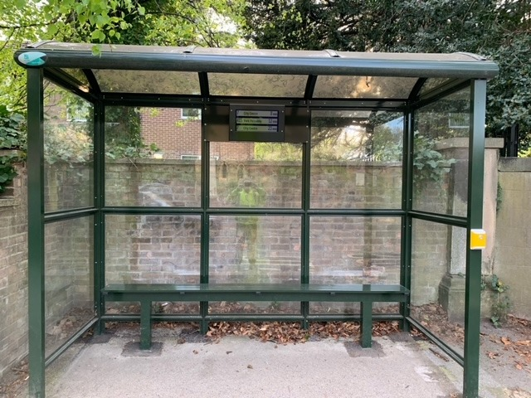

Charter Standards
We feel that it is time to set out what we feel are the standards which York’s bus stops should meet. These are as follows:
- All stops to be sited as close as possible to the location(s) they serve, with a clear flag (sign) – preferably on the shelter if one is provided – and clearly visible from at least 200 metres away

- All bus stops should be within 400 meters of housing development on both sides of the road.

- Bus stops in built-up areas should be no more than 400m apart.

- All routes to significant destinations (employment locations, shops, leisure facilities) and stops which average more than 20 passengers per day and termini to offer shelter and seating

- All stops to have lighting and mains, battery or solar powered electronic timetable boards, and waste bins where practicable

- Clearer printed passenger information at stops in legible type, readable at night, and with Braille option

- Clear safe access for wheelchair and pram users

- Audible warnings of approaching buses and their destinations at all inbound and termini stops - activated either by button or automatically by oncoming vehicles.

- No cycle paths to cross between footpaths and bus stops without speed restricting measures

- All shelters should provide adequate protection (including end panels) from inclement weather, be vandal-proof and lit.

- No shelters should have end panels obstructing the view of oncoming buses with advertising material.

YBF 110822

