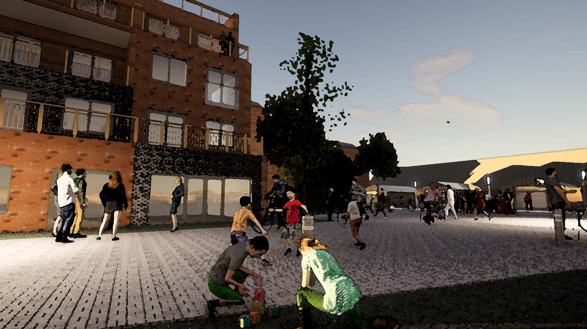
YoCo Community Plan for York Central
Welcome to York Central. Children are playing on the streets. You can hear birdsong. It is vibrant and peaceful. Many different ways of life co-exist. It is a community made through exchange. York Central works with the failures in York’s unequal economy to circulate community wealth and make housing forever affordable. It offers a new social contract for tourism in York, using co-owned accommodation and attractions to reinvest profits for community benefit. It makes all of this possible through dynamic and powerful connectedness, where activities are organised to be mutually supporting in order to create thriving and happy neighbourhoods.
These new neighbourhoods will only have children playing in the street and birds will only be heard singing if we reorientate the economic structure of York Central. But this York Central is possible - we show how in this YoCo Community Plan for York Central.
Introduction
The YoCo community plan starts with the approved outline planning consent - this is what we know to be certain. But the approved outline planning consent is only an outline. The planning application was framed in the likelihood that the development would progress in a conventional way, with infrastructure completed by the Partnership, and the buildings and spaces built by individual developers acquiring the identified sites.
The YoCo community plan takes the outline planning consent and proposes a radical approach to developing the whole site in a coordinated, integrated way for the benefit of the city and its people. It contains mechanisms to ensure opportunities for local economic development which engages people and organisations in York, intervening in the city’s significant economic and housing inequalities. Crucially, it’s a sustainable vision of a new part of the city fit for the challenges of the 21st century, which creates enabling connections between economies, social relationships and environments and pioneering community-ownership and distributive approaches that in time will start to shape the city as a whole.
The community plan is structured below in four clear sections:-
- What will it be like? Take a walk through this new place, exploring how it looks, feels and works.
- How do these ideas connect and make each other possible? Explore how the interconnected ideas in the community plan enable this alternative York Central.
- What are the specifics of the plan? Delve into detail on the various specific interconnecting elements, supported by links which spell out why we believe they are feasible, including where they are already being shown to work elsewhere.
- What happens next? Find out how you can support the YoCo Community Plan for York Central and get involved to make this plan a reality.
Please read the community plan and use your vote on the Combined Choice website to call for it to be made to happen.
Sign up to Combined Choice. Vote for the YoCo Community Plan for York Central.
What will it be like?
Welcome to York Central.
You have arrived by a path through one of the wilder green areas from the Leeman Triangle area. You have walked by the thriving allotments with the large and busy sharing point for vegetables and tools - this is very active green space. You’ve also passed by teenagers hanging out in the more hidden margins and have heard birdsong and the wind in the leaves of the many growing trees.

As you enter one of the distinctive neighbourhoods there is a buzz, a vibrancy, a sense that many diverse people living different lives are successfully co-existing. Young children play in the streets. Adults stand chatting having just bumped into each other, sit working at the corner cafe or have eyes on the street from generously-sized balconies. Cars are a rare sight - kept to the edge in a multistorey car park near Water End, only interrupting the games or conversations to enable access for the neighbourhood's older and disabled residents. Homes open onto the street giving glimpses of light, warm and welcoming rooms, but the streets and spaces feel like they’re owned by their neighbours too (it turns out that they actually are). Everywhere looks well looked-after – there’s a mix of tenure but the aim is “forever affordable” – whether via mutual ownership or covenants which prevent individual profit from York’s malfunctioning property market.

It’s less than a gentle fifteen-minute walk across the neighbourhood but you realise you can buy food, get a coffee or a pint, take a class, walk to a nursery or walk children to after school activities, and many of the buildings are a hum of business activity near street level. You pass the Centre for Learning – linking the three local primary schools with the universities and supporting collaboration and creativity in all forms. It also has a communal teaching kitchen and a large community garden for food growing, and is a source of different smells on different evenings as foods from different parts of the world are cooked bringing people together. On other nights different beats, dances, desires, faiths and hopes are played out here – and across the neighbourhoods – as people with different affinities, sexualities and identities can be themselves, feeling both safe and free.

Almost-car-free routes encourage you to explore, equally easily on foot, using a wheelchair, whether blind or partially sighted or on a bike, and as you turn down Leeman Road and pass through the all-hours access route through the National Railway Museum’s new central hall you marvel at the majesty of trains you can see beyond the glass - enjoying movement through a museum of movement. After dark people of all genders and ages know they can get themselves home under their own steam confidently and alone if they so choose and knowing that the highlight will be passing those trains, magically lit up.

You find yourself in the new public square that connects the museum and railway station. It is car free with those on foot, with buggies or using wheelchairs very occasionally stopping to let a bus or the little Very Light Railway train through, taking people to and from the car park and outlying suburbs. Empty of cars the new museum square has real purpose - for music, art installations, events, stalls and for people watching. It draws the crowds.

The railway station connects this new part of York with the York that has long existed and is always evolving both inside and outside the city walls. There is now no question that whichever way you leave the station you know you have arrived in a place which is distinctively York.
What the connections? How do they enable each other?

Throughout the My York Central public engagement and the development of YoCo people have shared ideas of what they’d like to be able to do on York Central. Many of these ideas of what it will sound like, smell like and feel like have been captured in the narrative above. A number of ideas were often shared and resonated widely. These included children being able to play in the streets, hearing birdsong, or ensuring housing was really affordable and not used for profit.

We have developed a diagram that help communicate this interconnectedness and the ways in which one thing is enabled by a set of other dependencies. For children to be playing on the street, for birdsong to be heard or for there to be forever affordable housing what is needed is a re-engineered approach to the economy on York Central.

Let’s take you on a couple of routes through this map of connections.
- Here is one route. For children to be playing in the street, the streets need to be almost free of cars. For that to happen there needs to be a shared edge-of-site approach to parking in a multistorey. For that to happen there needs to be strategic coordination across the York Central site in terms of building and long-term management.
- Here is a second route through these connections. For children to be playing in the street there needs to be adults around having eyes on the street and a sense of a shared responsibility for the children of the neighbourhood. For this to be possible there needs to be a diversity of ages and background living in, working in and moving through the street to local shops/cafes and for that to be possible we need economic design which moves resources around to cross-subsidize and enable affordable housing and live-work spaces.
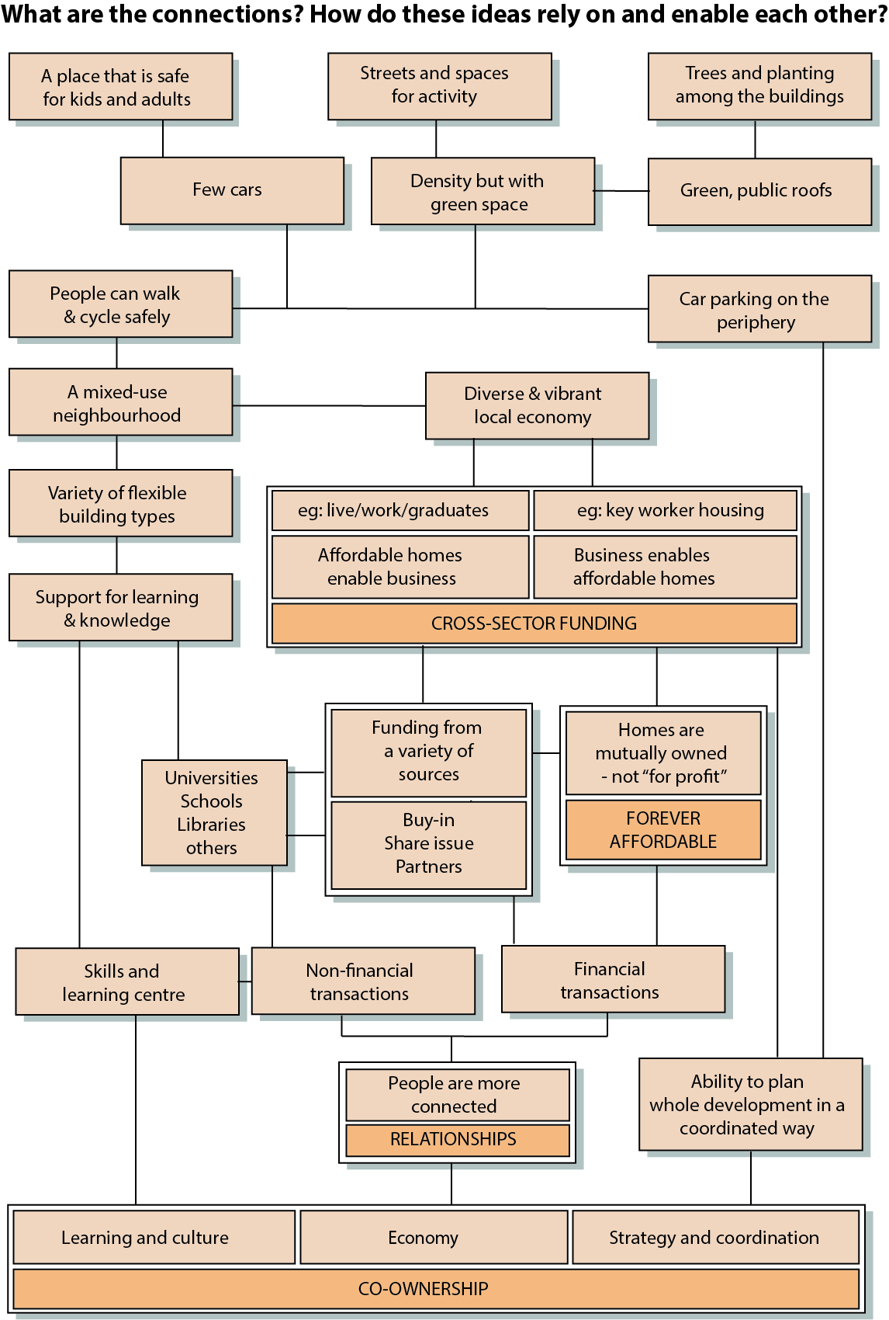

The Specifics of the Plan
Economy
The economy on York Central will depart fundamentally from the conventional development model which fails cities and individuals alike. It will be genuinely sustainable, enabling forever affordable housing, start-up creation and spaces for growth of local businesses as well as for life and work to be integrated well, and for community and co-operative activities such as growing, cooking, childcare and intergenerational learning to thrive.
YoCo is aware that any proposal needs to be seen as feasible and economically literate by York Central Partnership and potential funders. The York Central Partnership Project Director has spoken of the wish to source “patient capital” and the proposals below envisage a partnership between funders, landowners and community which seeks a negotiated economic structure that benefits all.
- A Really Strategic Board for York Central: Create an expanded strategic board made up of stakeholders from across the community to enable active dialogue and planning. This will link the landowners, current and future residents and business owners with a long-term sustainable economic purpose. This will enable the development and design of the economic and governance approach effecting actual decision making that will help realise the vision in this community plan.
- Local wealth from tourism – a new social contract: Model the basis for a new social contract for tourism in the city by including community-owned visitor accommodation and visitor experiences as a means of redistributing wealth. Growing out from the National Railway Museum’s new development, York Central will be creative in interpreting the local site-specific railway heritage and activating the memories and knowledges of those whose lives have been in the industry.
- Community investment: Enable people who live and work in York to invest, both for financial return and to enable innovation in their city (such as low-cost start-up space), facilities which benefit business and community alike (such as cultural / workshop space) and facilities for businesses which benefit nearby communities (such as energy-efficiency and retrofit).
- Ideas Neighbourhood: Design York Central to promote an “Ideas Neighbourhood” with a rich and resilient network of related businesses (especially digital media) where collaboration is encouraged - through shared spaces and design for interaction (cafes and streetscape, fast overall WiFi coverage). Crucially, support, knowledge and training provision from an overarching coordinating body involving the universities and others. This would also encourage funding input from those same sources to ensure accommodation for business start-ups and development, tech accelerator facilities and more.
- Turning ideas into businesses: Develop partnership with universities to enable affordable accommodation for graduates to improve graduate retention and to seed the local business start-up process - including live/work units. Work with existing bodies supporting start-ups - including Spark:York - to develop start-up space from which businesses can grow and relocate locally as accommodation is built. Part of this would be enabling different types of businesses including community interest companies.
- Co-operative purchasing: Enable local shops to reduce waste and product costs and to support local purchasing which is affordable.
- Public sector anchor institutions: Encourage local agencies (CYC, NHS, Emergency Services, Schools, colleges and Universities) to prioritise local business when procuring products and services. For example a local cleaning company could be employed to clean offices, hotels and the museum. This would generate and retain money in the locality, and would be desirable but not essential to make this model work.
How we know this can happen:-
- Notice which businesses will make profit - and make sure they are community owned. Spark:York has identified that a cross-subsidy process is useful. In their Piccadilly site, Spark found that the businesses selling alcohol made most profits but the food sellers attracted people in, who then became customers at the bar. In a future economic design, Spark would ensure the bar is collectively-owned and profit sharing. There is something to learn here for York Central where someone will make money from hotels and alcohol, how can this profit be distributed, shared and enable community activity?
- Make space for local businesses: Hackney Bridge is a brand new, canalside public destination close to Hackney Wick featuring workspace, public facilities, events, markets, restaurants and bars, giving local enterprises the space they need to thrive together. https://hackneybridge.org/
- Studio space in high-land value economies: Creative Land Trust in Hackney has found an economic model to enable affordable studio space for artists. Stone Studies https://creativelandtrust.org/properties/stone-studios/
- Community share issues for community-led development: Headingley Development Trust has used community share issues to support a range of initiatives and also works with local businesses, having helped set up the Natural Food Store on North Lane, now a successful independent co-operative. https://hdtleeds.org.uk/
- Anchor institutions supporting community-wealth building: The "Preston Model" is a term applied to how the council, its anchor institutions and other partners are implementing the principles of Community Wealth Building within Preston and the wider Lancashire area. You can read all about it at https://www.preston.gov.uk/media/1792/How-we-built-community-wealth-in-Preston/pdf/CLES_Preston_Document_WEB_AW.pdf?m=636994067328930000

Living
Homes on York Central will be for living and not for investment. A mix of tenures and financial models on York Central will respond to financial realities and differing demands while prioritising forever affordable homes which address York’s housing crisis. This envisages partnerships between cooperative groups, Registered Providers and others, but ensuring that the overall economic balance is regulated so that income from community-owned businesses, commercial spaces and infrastructure on York Central enables more affordable housing for those who need it. All buildings will be to Passivhaus standard or agreed equivalent, providing low running costs and banishing fuel poverty.

- Creative ways to ensure forever affordable housing: There will be a variety of forms of tenure but an underlying principle that homes should – through a range of measures – remain affordable into the future. This would include:-

Mutual Home Ownership: use of mutual ownership so homes and other accommodation are owned collectively and profit isn’t extracted when people move on.

Range of tenures: use of a range of tenures to address affordability at a range of incomes. This could include not just social rent, mutual home ownership or market sale.

Cross-subsidy of market sale: exploring ways to include market sale housing which benefits the neighbourhood – whether by cross-subsidy of affordable homes or investment in neighbourhood infrastructure, or by creating and training local construction businesses to generate local income and skills.

Patient capital – that does not quickly extract profit: working in partnership with funders to ensure investment generates long-term returns while enabling an inclusive community.

Homes for living not investment: where necessary using covenants to prevent private profit from buy-to-let and holiday lets.

The benefits of high density: designing rich, mixed use neighbourhoods with homes above commercial and social floorspace to spread the cost of land and infrastructure – while creating a walkable neighbourhood.

- Build in low running costs with high environmental standards: Homes will not just be affordable to buy or rent but also be cheap to run – this can be done through Passivhaus standards and designing integrated neighbourhoods with shared energy systems.
- Intergenerational living and intergenerational communities: York Central will enable intergenerational living and for intergenerational communities. This will also enable opportunities for informal learning between people of different ages and backgrounds.
- Centring accessibility and inclusion: This new part of York will remove disabling physical and social barriers that prevent people living flourishing lives. Issues of mobility, level access and easy employment of local, well-paid professional care staff will all be designed in terms of homes, streets, transport infrastructure and the York Central economies.
- Facilitating well being: Integrated facilities that link GP, childcare, community and cultural facilities will be provided.
- Really living where you earn your living: Paid work and life are integrated - this is key to creating fifteen-minute neighbourhoods and lively, safe streets and public spaces. This would include live-work spaces and designing for homes to change over time to enable different kinds of work. It would also include a distributed approach to economic activity on York Central, so there are small workspaces and commercial spaces across the site to bring life and dynamism to each neighbourhood.
- Faith on York Central. Space will to be set aside on York Central for faith organisations. This has the potential to work through identifying big interconnecting themes that link people of different faiths and those with none about care for each other and repair of our relationship with the planet.
- Connected neighbourhoods, linking existing communities and the communities-to-come: York Central will face outwards and connect to and link the existing neighbourhoods in Leeman Road and Poppleton Road.
How we know this can happen:-
- Forever affordable homes: Mutual Home Ownership (MHOS) has been proven on co-housing projects beyond York - most notably (and locally) LILAC in Leeds which was built in 2013. This models takes housing out of the commercial market forever. https://www.lilac.coop/ See www.yorspace.org
- Linking community facilities and affordable housing: Vienna has fostered a thriving community housing sector which regularly builds high-quality developments mixing affordable homes (in many cases for very mixed groups including refugees) with ground-level facilities for the residents and the existing local community. https://www.wohnbauforschung.at/index.php?id=12&lang_id=en
- Low running costs through high standards: Passivhaus is growing as a standard upon which to build zero-carbon homes - the city’s own Housing Development Programme has embraced the standard and will be building to it elsewhere in York. Recent research suggests the real costs of Passivhaus above building regulations minimum are decreasing and now probably between 4-8% https://www.passivhaustrust.org.uk/UserFiles/File/research%20papers/Costs/2019%20PHT%20Costs%20Summary%20web.pdf in Heidelburg, the entire Bahnstadt development (on former railway land…) has been built to Passivhaus standard. https://www.heidelberg-bahnstadt.de/1003686.html
- People of all ages: The benefits of intergenerational communities have been well established by existing communities - for example The Kohab (https://www.thekohab.com/) blogged at https://www.housinglin.org.uk/blogs/Intergenerational-Living-a-new-way-of-living-the-old-way/
- Integrated facilitates linking health and culture: Bromley-by-Bow have create space for linked services ‘based on their individual needs, because we know that health is primarily driven by social factors, not medical ones’. https://www.bbbc.org.uk/about-us/
Movement
York Central will be for people not cars. It will be a place where you can breathe, where birdsong can be heard, where children play in the streets and everyone of all ages can walk, cycle and use wheelchairs safely either all the way into York or to the train station or to bus stops with regular services.

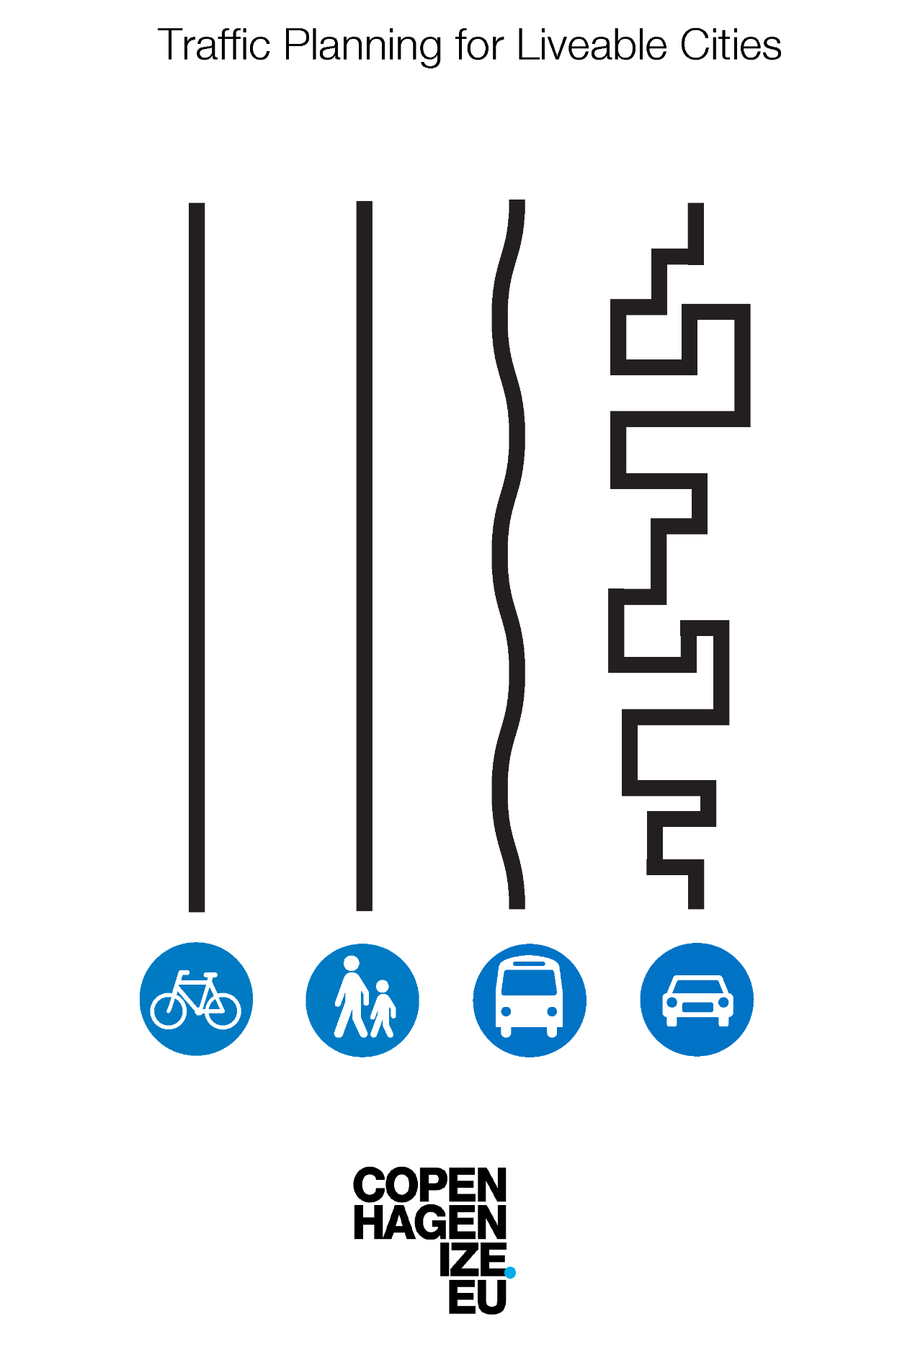
- Implement the transport hierarchy: The City of York Council’s ‘transport hierarchy’ should be enacted in a concerted and sustained way. Another way of looking at this is depicted in this diagram.

This diagram is from Copenhagenize - a blog and now design agency. Copenhagenize say: ‘This is our simple traffic planning guide for livable cities. Make cycling, walking and public transport the fastest way from A to B and make driving a pain in the ass and you have basically the most effective way to change the mobility paradigm for the better. It's that simple’ As a fundamental principle, getting around on foot or by bike is the easiest, most direct way. Traffic movement is possible but not the priority. Image credit: it is reproduced under (CC BY-NC-ND 2.0).

- Easy to walk: The whole site will be as easy to walk as possible and paths will be designed to be responsive to where people need to walk. All streets will be safe for children to play in, making all streets “play streets”
- Safe and convenient to cycle: There is a network of direct segregated cycling routes into and through the site which connect to routes to the city centre and riverside. A key principle is for more public space to be allocated to pedestrians and cyclists to limit any feeling of competition between those on foot and those on bikes.
Specifically York Central will address the following issues:-
River walk and cycle path through Leeman Park
A specific issue here is the importance of the pedestrian and cycle route through Leeman Park, next to the Ouse. The route needs to be wider, well-lit and improved to avoid flooding. This will need to happen before the closure of Leeman Road.
National Railway Museum: 24 hour walking and cycling through route
A museum of movement will celebrate movement and give 24 hour access to its incredible collections by having a route through the new extension, facilitating 24 hour walking and cycling access and enabling magical experiences for all as they walk and cycle through.
New connections
New pedestrian and cycle connections will enable movement across the railways, connecting Holgate and Acomb, York Central, the Ouse and beyond.
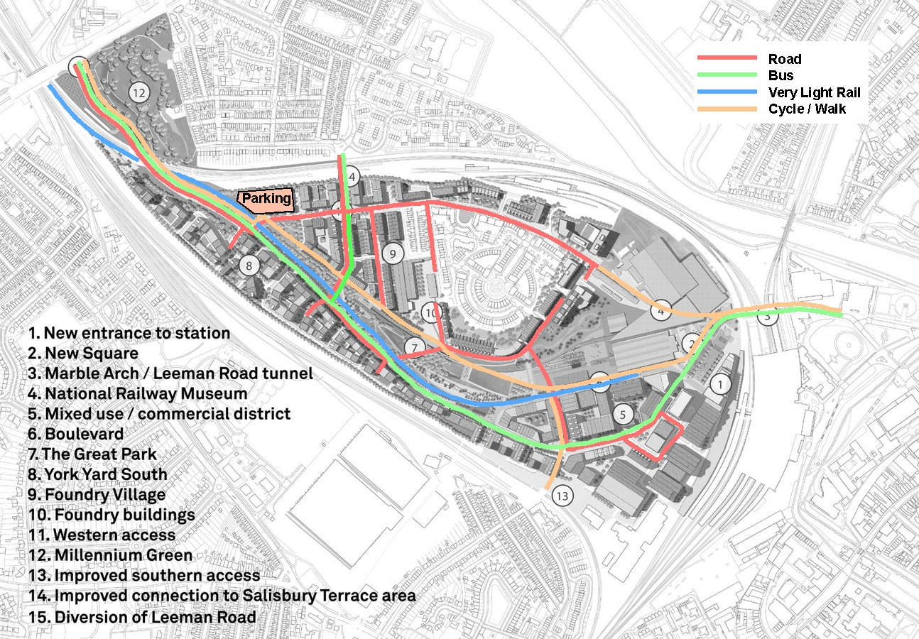
Above:- An illustration of how we can take the outline consent and re-purpose the routes to prioritise walking, cycling and public transport. This reflects the city’s transport hierarchy (and the Copenhagenize diagram above).

Cars: The number of cars coming through York Central will be minimised:-
- Access to the site by car will solely be from Water End.
- No on-street or on-plot parking; speed management via design of streets
- Residential parking will be concentrated on the edge of the site close to Water End; a compact multi-storey car park part-funded by purchase at-cost of parking spaces by those who want them.
- A car sharing system could be set up to reduce the need for individual ownership of cars.
- Station parking replaced by use of Park and Ride buses and use of relocated multi-story car park and electric shuttle vehicles.

Public transport: York Central will create a high-quality priority public transport spine. This will include:-
- Bus/taxi gates at Leeman Road Tunnel to prevent private cars.
- Park and Ride buses diverted through site going to and from York Railway Station
- At least 6 buses per hour will pass through the residential community
- Traffic is as far as possible separated from buses, and where not possible buses have priority over other traffic
- Plan for the future - ensure a Very Light Rail route is reserved through the site for future connection to the Park & Ride (making it Park & Rail) and other developments along and off Poppleton Road.
Freight and servicing: The number of lorries and vans coming through York Central will be reduced:-
- Lorries and vans will only have access from Water End
- Servicing points for commercial property are concentrated in one place which is off the road and then taken to specific businesses by small vehicle or bike.
- Residential delivery will happen to a number of centralised collection points, with support for those that cannot come and pick parcels up themselves..
Refuse collection: Refuse will be collected from a central point to reduced lorries coming through the site, The refuse point will also be a point where exchange, repair and recycling can happen.
How we know this can happen:-
- Getting people out of cars: True walking/cycling priority has been part of the design process in Copenhagen and many other European cities for decades. For example in Copenhagen almost one third (29%) of all journeys are done on a bike, and 41% of commutes (to work or study) are the result of pedal power, and that’s an increase of 22% in fifteen years. https://www.weforum.org/agenda/2018/10/what-makes-copenhagen-the-worlds-most-bike-friendly-city/
- Movement through a museum: Amsterdam’s Rijksmuseum has had a route through its heart since it was built, described thus:- “The museum was built in the 1880s on building land provided by the city of Amsterdam. In return, the city set the condition that a public passage to the new neighbourhoods south of the museum would be included in the building. The passage became an important and well used route for pedestrians, cyclists and cars. In 1931 cars were banned because the vibrations they caused would damage the building. (Now) the passage is a safe, direct and comfortable bicycle connection used by thousands of cyclists every day.” https://bikecity.amsterdam.nl/en/inspiration/rijksmuseum-passage/
- Parking at the edge of a city quarter: The Vauban development in Freiburg has over 5,000 residents who can drive to their homes (but not park there) and who can choose to own cars (but must pay the true cost of their space in a multi-storey car park on the edge of the neighbourhood). https://d1trxack2ykyus.cloudfront.net/uploads/2017/10/Vauban..pdf
- Very Light Rail: The city of Coventry is developing proposals for Very Light Rail, providing the benefits of conventional light rail at a fraction of the cost - https://www.coventry.gov.uk/info/113/regeneration/3152/very_light_rail
- Community funded infrastructure: Rotterdam’s 390m Luchtsingel bridge was built to unlock an urban site landlocked by road and rail. It was initially crowdfunded, with 8000 supporters buying planks of the timber structure which were embossed with their name. It was opened in 2015. http://www.luchtsingel.org/en/
Public Spaces and Green Spaces
Public spaces will enable people to come together, enabling freedom of movement and play. Green spaces will either be wild or productive, and streets will make use of space reclaimed from cars to bring trees and wildlife to places where people live and work. York Central will support wildlife and biodiversity, creating places to wander in solitude or hang out and it will create new allotments and community gardens for gardening and growing food.
- Not just ‘feeling ownership' - actual ownership: Public space will be held in common – with stewardship in the hands of neighbouring communities. It must enable people to do the outdoor things they want to do, individually and collectively - growing food, doing creative things together, and creating local economic benefits. This will require social infrastructure – a system of local decision-making - to make it work and to collaborate on good practice with projects across the country and beyond. All of this will benefit from a diverse and close-knit mixed community built around places where people meet, learn about each other, and collaborate.
- Public space will be playful: Outdoor public spaces will be designed to be used in a variety of ways which acknowledge that children make play from a variety of props, and that play is for adults too. Spaces will be designed to ensure everyone has comfortable places - irrespective of age or gender. Buildings will be designed to incorporate public space - rooftops with views and green landscaping. Playfulness and artfulness will go hand in hand, with space for music and arts.
- Spaces that foster creativity: Indoor public space is important too, both for local people and to draw in visitors and help the local economy. Creative space can serve local schools and similar groups during daytimes, available outside these times to groups and individuals at affordable rates. Again, coordinated provision of skills and knowledge would enable a community made through exchange – fostering an ideas neighbourhood.
- Freedom to move: Public space will be designed to allow independent mobility for all, including the young - avoiding the barriers created by main roads, and the quiet takeover of streets by individual car owners for parking.
- Green spaces will be wild: Trees will surround the buildings and line the streets, wilder and ecologically rich spaces will be created and connections to other green corridors planned for. Trees will be needed to capture carbon and provide shade as temperatures rise. Water will become a part of the local landscape, with sustainable drainage shaping landscaping within each neighbourhood. The new green spaces in York Central will seek to join up with existing green spaces such as Millennium Green and Holgate Community Garden.
How we know this can happen:-
- Land for shared benefit: The Life Sized City documentaries showed many examples of local communities taking over land for shared benefit - for example the Lande project in Montreal https://commoning.city/project/lande-montreal/
- Young people welcome: A number of cities have explored how to create skateable landscape - mixing opportunities for skating / skateboarding among the essentials of public space - https://kingpinmag.com/features/articles/skate-hull-hull-plans-become-uks-first-skate-city.html
- Independent movement for children and young people: Independent mobility for children varies widely between cities but much research has been done and clear recommendations are there to be followed https://www.nuffieldfoundation.org/wp-content/uploads/2019/11/7350_PSI_Report_CIM_final.pdf
- Public spaces for girls: Make Space For Girls has campaigned to emphasise the need for public space which suits teenage girls and to ensure that parks, play equipment and public spaces for older children and teenagers are not simply designed for the default male. http://makespaceforgirls.co.uk/

What happens next?
Thank you for reading the YoCo Community Plan for York Central. We are determined to bring this plan to life on York Central and we’d like your help to make this possible:-

- Sign up for Combined Choice
- Vote for the YoCo Community Plan for York Central
- Join YoCo
- Ask your friends and family to sign up to Combined Choice and Vote.
- Follow us on social media and share our posts

We need momentum and to show widespread community support so we can continue a positive dialogue about community-led development on York Central, so we can enthuse the landowners Homes England and Network Rail about the potential for real innovation on York Central and so we can ultimately secure funding to develop further these ideas, buy land and set up the community-led governance structures that will be needed.

York Central is a large development and what happens here will affect the whole of York.
This new part of York could be incredible. It could actively intervene in our city’s inequalities and pioneer a distributive approach to tourism by co-owning accommodation and commercial spaces and reinvesting profits to secure forever affordable housing. It could be a place of play and birdsong.

We like to be positive – this is why we have created a plan – but let’s just for one moment consider the big ‘why’. Why do this?

There is a version of York Central that would equally – like ours – be enabled by the existing outline planning consent. This is a place of only 20% affordable housing and 80% expensive buy-to-let flat and holiday lets and of people far away making money while our housing crisis deepens. A place of a business district that is dead after 5.30pm. Of car parks outside office blocks. Of chain hotels and bars near the station. Of traffic jams between the railway station and the National Railway Museum at rush hour.

We do not believe that anyone actively wants this. We are confident that York Central Partnership wants something different and better too and we look forward to working with York Central Partnership and any and all to create the York Central we have imagined here.

Another York Central is possible. A York Central of forever affordable housing, start-up spaces for local business, community learning, growing and allotments. A place of trees and birdsong and of play for all ages.

